OTEX FRAMEWORK

COMP7722 Major Project, semester 2 2016

Mark Gillard (2065050 / gill0235)

2016

OTEX

An OT-based text editor framework by Mark Gillard (2065050 / gill0235)

Contents

System Requirements 2

Launching OTEX Editor 2

Connecting to an OTEX server 3

Editing a document 4

Creating a dedicated OTEX server 5

Attributions 6

Source code 6

Appendix: OTEX Class Diagrams 7

# System Requirements

OTEX requires Windows 7 or higher, with the .NET Framework 4.5.2. Most systems that have not disabled windows updates will have this installed already, but if you need it you can download it here: <https://www.microsoft.com/en-au/download/details.aspx?id=42642>

# Launching OTEX Editor

Run OTEX\**x86**\OTEXEditor.exe if your machine is 32-bit, or OTEX\**x64**\OTEXEditor.exe if it is 64-bit. If you’re going to connect to an external server, you do not need to run the same platform’s binary as the server; the communication between clients and servers is platform-agnostic.

Once it’s running, you’ll see this:

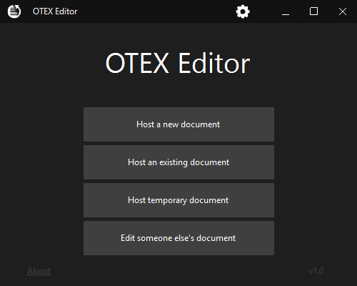

These three options allow you to edit a document and simultaneously host it as a public server so others may join you. “New” will start with an empty document, “Edit” will read in an existing document, and “Temporary” is the same as “New” but does not write anything to disk (the document is lost when you exit).

This option opens the server browser page, allowing you to see a list of public servers on your network. You may also directly connect via IP address.

* Selecting “New” or “Edit” mode will ask you to select a file to create/edit before the editor is launched.
  + **Note #1**: OTEX is a plain-text system, so attempting to force it to load binary files will have undefined results!
  + **Note #2:** OTEX Editor supports a wide variety of text file encodings on input, but writes files out in UTF-8 (without BOM).
  + **Note #3:** OTEX Editor supports three different line ending schemes: LF (unix), CR (?), and CRLF (windows). When files are first read OTEX Editor attempts to determine the scheme in use for the file by counting instances of each. If this fails it will fall back to the environment default (CRLF).
  + **Note #4:** Because of a limitation of the **FastColoredTextBox** control used by OTEX Editor, any tab (\t) characters in input files are replaced by 4 spaces.
* Selecting “Temporary” will launch the editor immediately.
* Selecting “Edit someone else’s document” will open the server browser (see next page).

# Connecting to an OTEX server

The OTEX Editor server browser page allows you to connect to OTEX Servers:

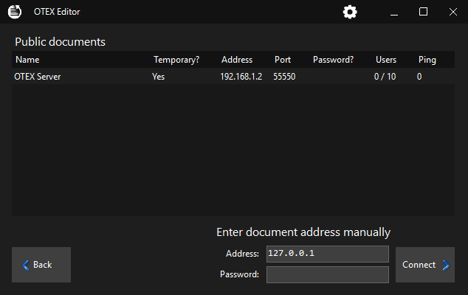

To connect to a public server, simply double-click it. If it requires a password you will be prompted for one.

To directly connect to a known server:

1. Type in the address in the “Address” field. If the server uses a non-standard port, indicate the port at the end of the address using **:00000** notation.
2. Type the server’s password into the Password field. If it does not require one, leave it blank.
3. Click Connect.

# Editing a document

Once connected to a server (or hosting one locally), you will see the editor interface:

Settings. Allows you to change your user colour, and how often OTEX Editor requests updates from the server.

“Leave session”, disconnects and returns to the main menu. **Doing this as the host will terminate the session for any other connected users!**

Server file name and address

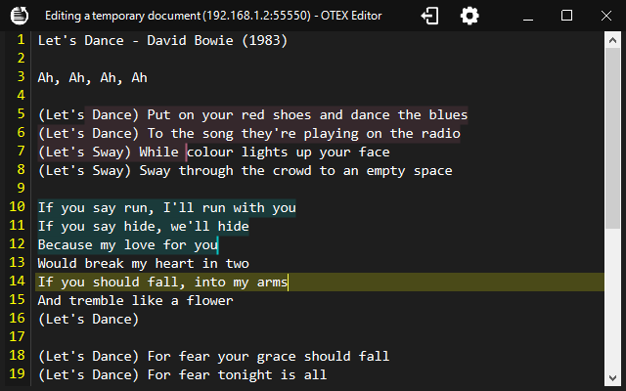

Line numbers (colour is your user colour)

Current line highlight (colour is your user colour).

Selection regions of other connected users, coloured according to their chosen user colour.

Edit text as you would in any other text editor, and see changes made by other users reflected in the document as you go. The Editor supports a large number of IDE-like hotkeys:

**Ctrl+F, Ctrl+R, F3** Find, Replace, Find Next  
**Ctrl+G** Go-To  
**Ctrl+Z, Ctrl+Y** Undo, Redo  
**Tab, Shift+Tab** Increase/decrease indent  
**Ctrl+U, Shift+Ctrl+U** Toggle uppercase/lowercase of selection  
**Ctrl+Shift+C** Toggles C-style comment prefix (//) of selected lines  
**Alt+Up, Alt+Down** Moves selected lines up/down  
**Shift+Del** Removes current line  
**Ctrl+B, Ctrl+Shift-B, Ctrl+N, Ctrl+Shift+N** Adds, removes and navigates bookmarks  
**Ctrl+Mousewheel, Ctrl+(NumpadPlus, NumpadMinus, 0)** Zoom  
**Ctrl+M, Ctrl+E** Start/stop macro recording, execute macro  
**Alt+F [char]** finds nearest [char]

# Creating a dedicated OTEX server

It is also possible to host a server without launching the editor interface. To do so, use the command-line dedicated server.

Run OTEX\**x86**\OTEXServer.exe if your machine is 32-bit, or OTEX\**x64**\OTEXServer.exe if it is 64-bit. Connecting clients do not need to be using the same platform as the server version you are running; the communication between clients and servers is platform-agnostic.

By default, OTEX Server will host a private temporary file session on the default port (55550) for up to 10 users. Customize it with command-line parameters:

**OTEXSERVER [file] [/EDIT|/NEW] [/PORT port] [/NAME name] [/PASSWORD pass] [/PUBLIC] [/MAXCLIENTS max] [/?]**

**file** Path to the plain text file to collaboratively edit. Omitting file path will create a temporary session (client edits will be lost when the server is shut down).

**/EDIT** If a file already exists at the given path, edit it (do not overwrite with a new file). This is default.

**/NEW** Opposite of /EDIT.

**/PORT port** Port on which to listen for new OTEX TCP client connections. Can be any value between 1024-55560 or 55565-65535. Default is 55550.

**/NAME name** A friendly name for the server. Limit of 32 characters (overflow is truncated).

**/PASSWORD pass** Password required to connect to this server. Must be between 6 and 32 characters. Omit to allow clients to connect without a password.

**/PUBLIC** Regularly broadcast the presence of this server to OTEX clients.

**/MAXCLIENTS max** Maximum number of clients to allow. Defaults to 10, caps at 100.

**/?** Prints help and exits.

Arguments may appear in any order. /SWITCHES and file paths are not case-sensitive.

# Attributions

OTEX Editor uses a diff generation package called **DiffPlex** to create the client-side OT operations when the text is edited by the user. DiffPlex can found on [GitHub](https://github.com/mmanela/diffplex) and [Nuget](https://www.nuget.org/packages/DiffPlex/).

OTEX Editor uses a very powerful RichTextBox alternative called **FastColoredTextBox**, which helps provides a lot of the more advanced features of the editor interface. FastColoredTextBox can found on [GitHub](https://github.com/PavelTorgashov/FastColoredTextBox), [Nuget](https://www.nuget.org/packages/FCTB/) and [CodeProject](http://www.codeproject.com/Articles/161871/Fast-Colored-TextBox-for-syntax-highlighting).

Icons used within OTEX Editor are variously sourced from websites like [Iconfinder](https://www.iconfinder.com/) and [Flaticon](http://www.flaticon.com/), or created by hand. Any icons sourced from icon repository websites were selected based on “free for commercial use” licenses (i.e. I saved myself from having to remember to specifically credit every single one).

The OTEX Framework uses a form of Operational Transformation called the “NICE” approach. See:  
Shen, Haifeng, and Chengzheng Sun. "Flexible notification for collaborative systems." *Proceedings of the 2002 ACM conference on Computer supported cooperative work*. ACM, 2002.

# Source code

The OTEX Framework is built in such a way that the Client, Server and ServerListener are all fully self-contained and implemented class objects, only requiring user code to “plug-in” to it by subscribing to the desired events. Case in point: the dedicated server application just an **extremely** thin command-line-wrangling wrapper around OTEX.Server. Similarly, the editor application is a relatively lightweight application too (though, any code requiring the manipulation of user interfaces is necessarily slightly more complex than a simple command-line application).

Code for the OTEX framework can be found on GitHub: <https://github.com/marzer/OTEX>.

**Note for COMP7722:** I havethoroughly commented the code, and specifically noted where something is relevant to the topic. These notes can be found by searching the C# files for the string “COMP7722”.

The code relies on a utility library (**Marzersoft.dll**), which is a personal library of useful classes, extensions and wrappers I’ve built over my years working with C#. It’s not open-source, but OTEX can be compiled by linking against the Marzersoft.dll files included with the OTEX distribution.

# Appendix: OTEX Class Diagrams

